# Research

Two of the most successful idle games in recent years are Tiny Tower and Fallout Shelter.

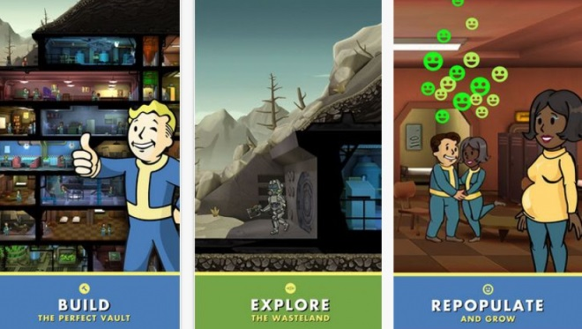

Both of these games focus on management mechanics coupled with the usual attributes of an idle game. As such the focus of both games is to use an in-game currency to set tasks and construction orders to expand either your “shelter” or your “tower”. The in-game currency(ies) is generated over time and tasks take varying amounts of time to complete ranging from several seconds to several days or even weeks, these are both examples of the games using fun pain to encourage the use of premium (paid for) currency(ies) which can be used to remove waiting as is common in many idle games.

These games have done very successfully and the core loops can be extracted for creating habitual behaviour.

## Core Loop

Trigger: Previous tasks complete (Notification)

Action: Select completed tasks

Reward: In game currencies, expansion on in game property, potential to do more things than before ((Endless) Progression)

Investment: Spend currencies on setting new tasks to be carried out

## Additional Mechanics

This loop ensures that players continue to return to the game, though these games also have additional mechanics for players to interact with while they are in the game; Fallout Shelter has additional mechanics involving managing the main ones being to manage the population through breeding and managing fully AI driven missions into the unknown; Tiny Tower has a simpler mechanic to keep players engaged while they are playing, an elevator on the left side of the screen often contains people from your building and players are rewarded for dragging the elevator to the floor indicated by the character in the elevator.

# Design

## Concept

The core loop from these games is themed around establishing, nurturing and expanding an insect hive/colony. For the purpose of this design document the insects will be referred to as ants although a revised version of this document will contain information on the research and construction of an alternate character species of our own design but with ant like behaviour.

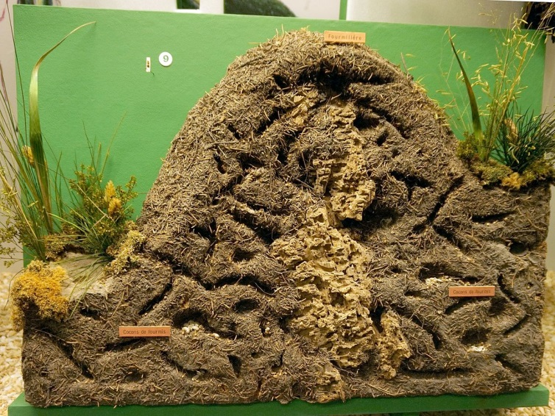  
Cross section of an ant colony

Ants construct colonies to live in which is a fact that most people are aware of which gives the potential for powerful affordances when combining the concepts. Ant colonies consist of tunnels and chambers which in a game environment can be made to function in the same ways as the Vaults in Fallout Shelter and the Towers in Tiny Tower.

Fallout Shelter Vault

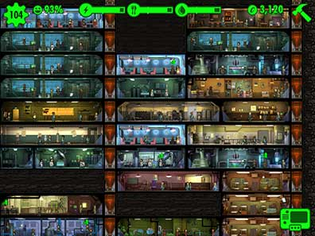

Chambers of different functions can be built to expand the colony which continually gets larger as the player expands to an indefinite amount similar to the Vaults of Fallout Shelter. Different chambers provide different resources to expand the colony and must be managed to ensure the colony grows without being short of any resources they need to survive, these resources would likely be related to the needs of ants; food, eggs, etc. These resources have a collection rate and maximum storage amount in relation to the number of chambers dedicated to that resource. Therefore an additional trigger as well as the notification of completed tasks is the notification of maxed out resources ready for player to spend on expanding their colony.

## Additional Mechanic

On occasion the colony will be attacked by other insects inspired by those that attack real ant colonies. When this happens a notification will be given to the player and when they next return to the game they must click the attackers to defeat them. While the colony is being attacked resources are generated at a reduced rate but upon defeating all the attackers a reward is given to the player. As with Fallout Shelters exploring mechanic this is meant to provide an additional habitual loop to attract more returning players by introducing an additional, trigger, action and reward.

## What does the Player do?

Upon returning to the game through a notification or otherwise a player will see their colony and all the completed tasks will be clearly visible and clickable to receive their rewards.

From there players can navigate using their mouse around their colony and by clicking on different UI elements can set new tasks to be completed; players must manage the resources of their colony which are spent in order to begin tasks.

Additionally when under attack players must click on the enemies to repel them.

## Resources

Resources to be managed are population, food, and building material. In order to generate them the rooms associated to that resource can be turned on or off. While on they begin producing the resource over time while using some of the population, the population slowly generates over time and in order to have enough population to complete other tasks the rooms can be toggle off by clicking on the room while it doesn’t have a reward to give.

## Mood Board

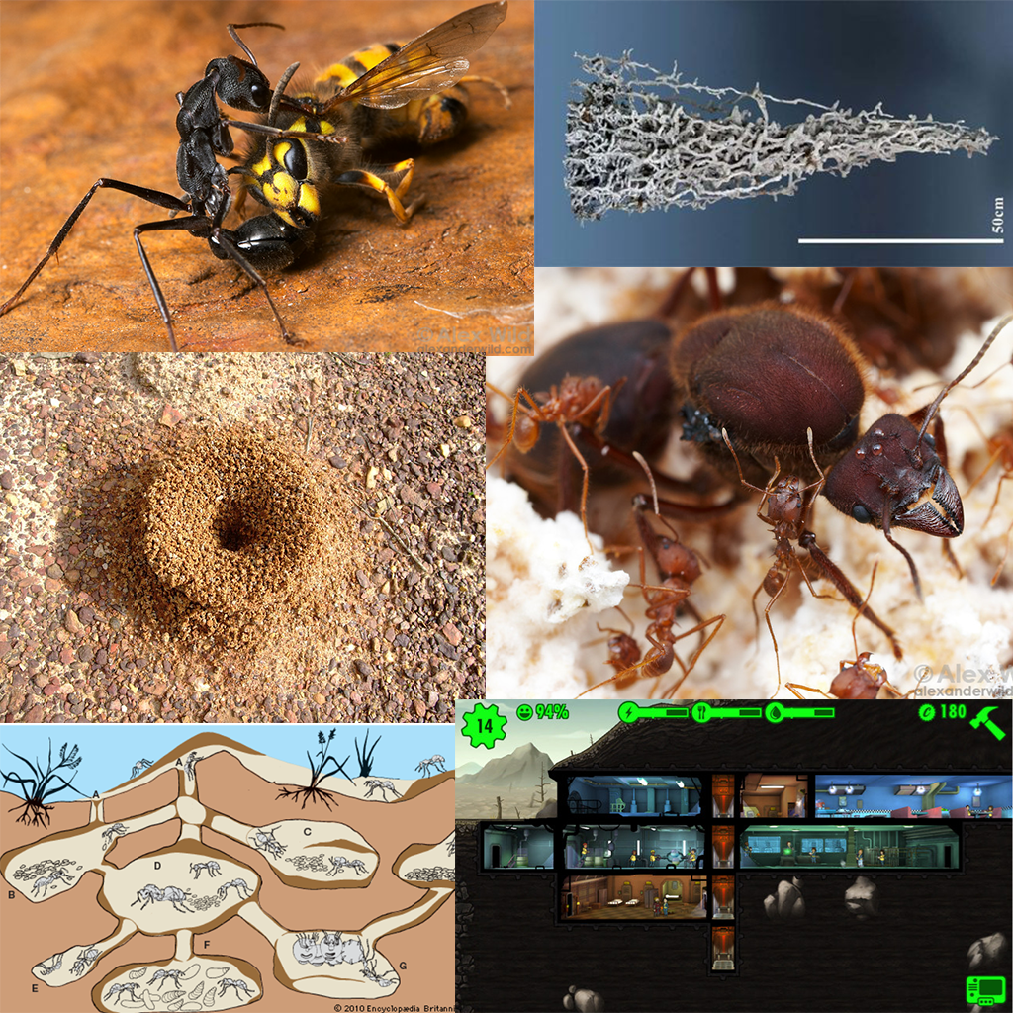

## UI Mock

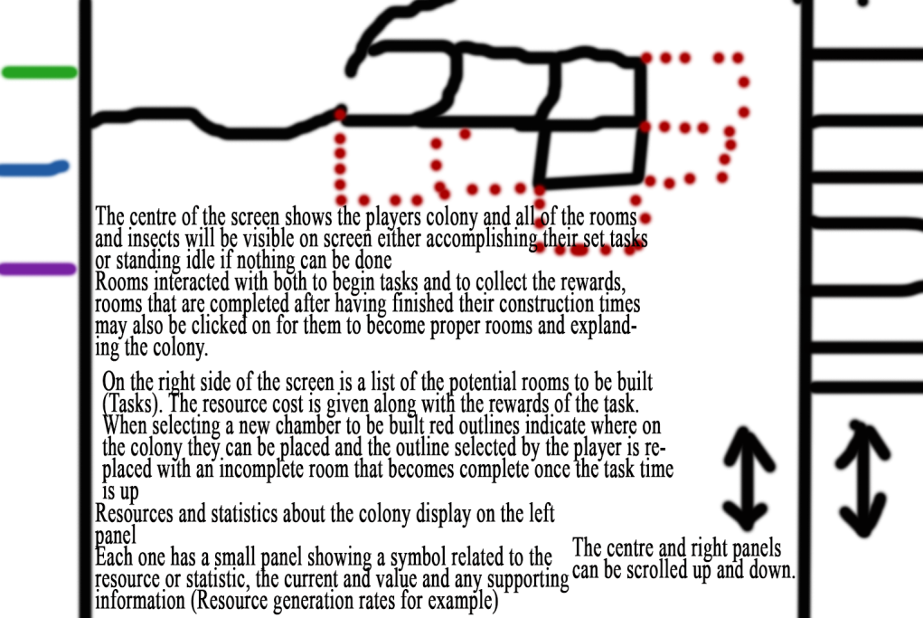

## References

For Document

Tiny Tower Banner

tinytower.wikia. (NA). Tiny Tower Wiki. Available: http://tinytower.wikia.com/wiki/Tiny_Tower_Wiki. Last accessed 02/10/2017.

Tiny Towers Gamestill

Steve. (2011). Tiny Tower Guide, Walthrough, Strategy, and Hints.Available: http://appsaga.com/tiny-tower-guide-walthrough-strategy-and-hints/. Last accessed 02/10/2017.

Giant Vault Shelter

moop2000. (2015). Fallout Shelter Vault 0. Available: https://imgur.com/gallery/jTfrr. Last accessed 02/10/2017.

Fallout Shelter Promotional Image

Ed Nightingale. (2015). Why Fallout Shelter is the darkest mobile game ever. Available: http://www.denofgeek.com/games/fallout-shelter/35877/why-fallout-shelter-is-the-darkest-mobile-game-ever. Last accessed 02/10/2017.

Fallout Shelter Smaller

thelonegamer.net. (2015). Fallout Shelter: Unleashing my Inner Overseer. Available: http://www.thelonegamer.net/dlc/fallout-shelter-unleashing-my-inner-overseer/. Last accessed 02/10/2017.

Natural History Ant Colony

Tiia Monto. (2015). File:Natural History Museum - ant colony.jpg. Available: https://commons.wikimedia.org/wiki/File:Natural_History_Museum_-_ant_colony.jpg. Last accessed 03/10/2017.

Ant Map

marycsimmons. (2015). The Ants Go Marching…and marching…and marching. Available: https://authormarycsimmons.com/tag/ecology/. Last accessed 03/10/2017.

For Mood Board

Fallout Shelter

aronchick. (2015). Can you upgrade a room to merge it?. Available: https://gaming.stackexchange.com/questions/224661/can-you-upgrade-a-room-to-merge-it. Last accessed 05/10/2017.

Ant Hive Graphic

EncyclopaediaBritannica. (2010). colony: ant colony. Available: http://kids.britannica.com/students/assembly/view/144467. Last accessed 05/10/2017.

Ant Queen

Alex Wild. (NA). Queen Ants. Available: http://www.alexanderwild.com/Ants/Natural-History/Queen-Ants/i-5HKMCm6/A. Last accessed 06/10/2017.

Ant Hill

Fujifilm FinePix F100fd. (2013). anthill-ant-insect-nature-colony. Available: https://pixabay.com/en/anthill-ant-insect-nature-colony-140643/. Last accessed 06/10/2017.

Ant And Hornet Fighting

Alex Wild. (NA). Predation. Available: http://www.alexanderwild.com/Ants/Natural-History/Predation/i-DnJhDRL. Last accessed 06/10/2017.

Metal Cast

Pinterest. (NA). aluminium cast of ants nest. Available: https://www.pinterest.co.uk/pin/359373245246521743/. Last accessed 06/10/2017.